Class
41

Julia Barry, US Attorney's Office, Western Distr
Thayla Bohn, American Fidelity Assurance Co.
Misty Bradley, Jordan Advertising
Brandon Brooks, OKC Community College
Emily Brown, The Chickasaw Nation
Sommer Brown, OG&E
Josh Busby, Langston University
Bryan Carey, Lagoon Water Midstream
Talia Carroll, Oklahoma City University
Lindsay Clark, Valliance Bank
Jolene Curry, Flintco, LLC
Keenon DeLeon, Embark Consulting
Michelle Dennison, OKC Indian Clinic
Parker Dooly, Bank of Oklahoma
Josh Dougherty, CEC
Andrea Durbin, MA+ Architecture
Jill Farrand, Simon Property Group
Anthony Garcia, Raymond James and Assoc.
Matt Garner, Chesapeake Energy
Ashley Gockstetter, Love's Travel Stops
David Hardy, Oklahoma State Bank
Marsha Herron, OK State School Boards Assoc.
Candice Hillenbrand, Girl Scouts Western OK
Sheena Hollander, Express Employment
Garrett Jackson, Devon Energy
Brian Jennings, Oklahoma City Police Dept
A.J. Kirkpatrick, ADG
Megan Law, Rotary Club of Oklahoma City
Seth Lewis, Arts Council Oklahoma City
Lisa Macias, OUHSC College of Nursing
Javier Martin, PCI Energy Solutions
Keili McEwen, Tinker Federal Credit Union
Amy McLaughlin-Gray, Community Volunteer
Scott Newman, Oklahoma State University-OKC
Amy Parrish, Jameson Group, LLC
Bob Remondino, Neuroscience Specialists
Paige Ross, ONE Gas/Oklahoma Natural Gas
Jim Shane, Kirkpatrick Bank
Tyler Smith, BancFirst
Nathasha Stamper, Consultant
Kale Streeter, Wiggin Properties
Brianne Webb, Cristo Rey Catholic H.S.
Judy Wilson, Oklahoma ER and Hospital
Curtis Wilson, MILES Architecture
Adam Wisniewski, Visit Oklahoma City
Emily Xiao, McAfee & Taft
Lyndi Zavy, Rivers & Roads Organizational Dev.

Quality of Life

Thursday, March 14, 2024
8:00 a.m. – 5:00 p.m.

Oklahoma Contemporary Arts Center
11 NW 11th St

Dress

Casual

Please notify the LOKC Office, 463-3331 or czelley@lokc.org, if you will be absent for any part of this session.

Oklahoma Contemporary
11 NW 11th St

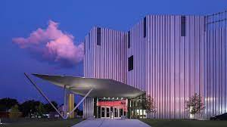

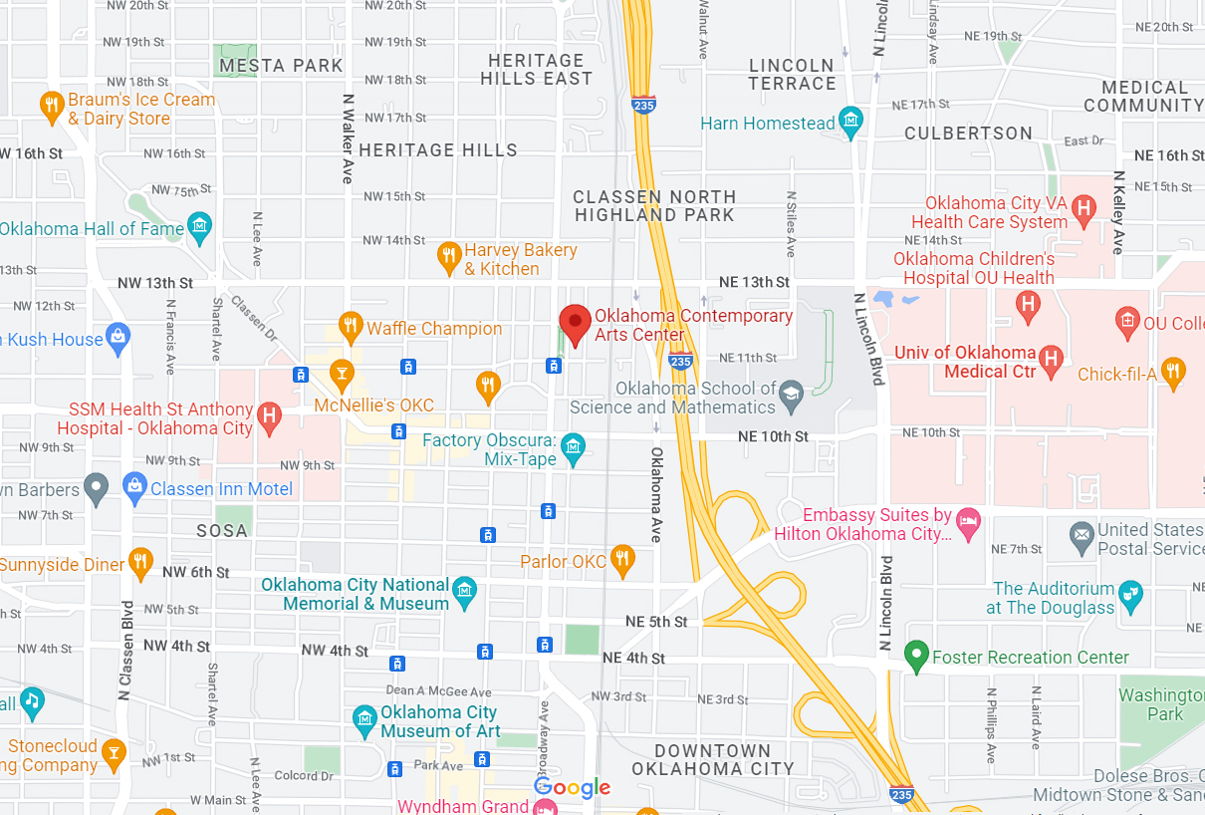

Agenda, Quality of Life
Time | Topic | Presenters
8:00 a.m. | Breakfast and Business Meeting | Cindy Batt  Program Co-Chair
8:15 a.m. | Class Bios  - Bryan Carey  - Tyler Smith  - Lyndi Zavy
8:30 a.m. | Welcome | Michael Myers  Interim Director  Oklahoma Contemporary Arts Center
8:45 a.m. | OK Contemporary Tours
9:45 a.m. | Travel  From Oklahoma Contemporary, 11 NW 11, travel to the Senior Health Center, NE 36th and Lincoln Blvd.
10:15 a.m. | NE Senior Health and Wellness Center Tour | John Pettis  Intergovernmental and Community Liaison  Community Health Centers of Oklahoma
10:45 a.m. | Sports and Such in OKC | Panel
11:30 a.m. | Travel  From the NE Senior Center, travel to the Jones Assembly, 901 W Sheridan.
11:45 a.m. | Lunch  Jones Assembly | Brian Bogert  Founder  The Social Order Dining Collective
 | “OKC’s Food Scene” | Panel  Jeff Chanchaleune  Ma Der Lao Kitchen  Victoria Kemp  Florence’s Restaurant  Courtney Mankin  The Social Order  Kindt Myers  Humankind Hospitality Services  Jenny Nguyen  Bún Box/Lee’s Sandwiches  Greg Horton, Moderator  OKC Business Writer and Food Lover
1:00 p.m. | Travel  From the Jones Assembly, travel to the OKC Zoo, 2101 NE 50^{th.} (0.8 mile south on Martin L King to Meyers Place and turn east, proceed to gate)
1:30 p.m. | Oklahoma City Zoo  - Behind the Scenes | Dwight Lawson  Executive Director and CEO  Oklahoma City Zoo and Botanical Garden  Candice Rennels  Director of Public Relations  Greg Heanu  Chief Marketing Officer
2:30 p.m. | Travel  From the OKC Zoo, travel to the Science Museum Oklahoma, 2020 Remington Place.
2:45 p.m. | Welcome to Science Museum Oklahoma  - Activities and Tour | Sherry Marshall  President and CEO  Science Museum Oklahoma
3:45 p.m. | Reconvene in the Goldman Room  For Pi Break
4:00 p.m. | Caucus | Cindy Batt  Program Co-Chair
4:30 p.m. | Board Bus  From the Science Museum Oklahoma, 2020 Remington Place, travel to Oklahoma Contemporary, 11 NW 11 to pick up cars
5:00 p.m. | Adjourn

