Human Services

Thursday, December 8, 2016
8:00 a.m. – 5:30 p.m.

United Way of Central Oklahoma
1444 NW 28th St.
Parking is available in the front and rear of the United Way, and also directly to the north of the building in the Cameron Building lot.

Dress
Business Casual

Please notify the LOKC Office, 463-3331 or info@lokc.org, if you will be absent for any part of this session.

Planning Committee
Debby Hampton, United Way of Central Oklahoma, President & CEO, Class XII
Jim Priest, Sunbeam Family Services, Executive Director, Class VII
Bob Ross, Inasmuch Foundation and Ethics & Excellence in Journalism Foundation, President and CEO, Class XXII
Dan Straughan, The Homeless Alliance, Executive Director, Class XXIV

United Way
1444 NW 28th St.
(Southeast corner of McKinley and 28th St.)
There is parking on both the north and south sides of the building.
You must enter from the north side (28th St.) only.
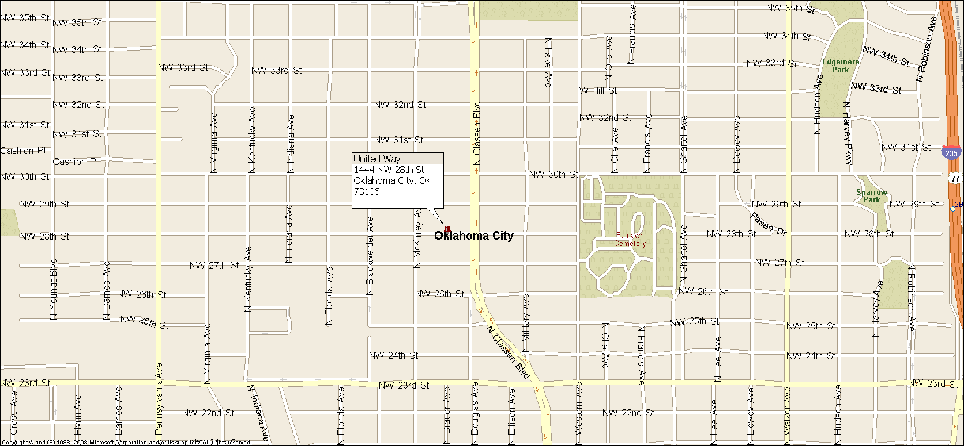
Google Map Link
http://maps.google.com/maps?q=35.49841,-97.536263&num=1&t=h&sll=35.49772,-97.535957&sspn=0.006295,0.006295&hl=en&ie=UTF8&ll=35.497723,-97.535956&spn=0.003027,0.006968&z=18
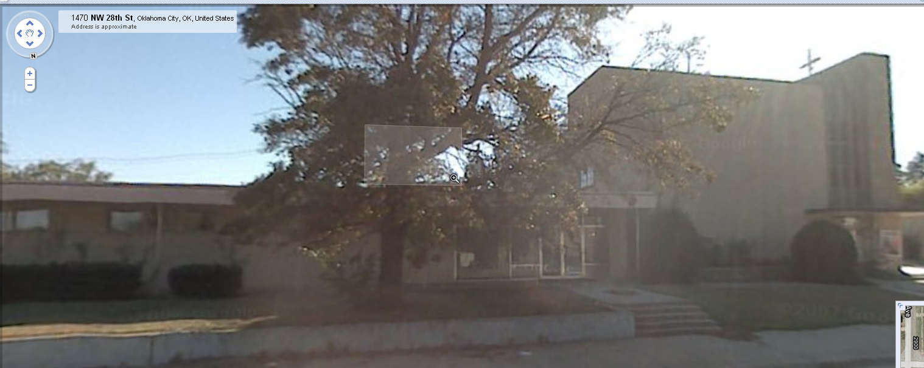

Agenda
Time |  | Topic |  | Presenter
8:00 am |  | Breakfast and Business Meeting  United Way of Central Oklahoma |  | Kelly Fry and Dave Lopez Program Co-Chairs
8:15 a.m. |  | Bios  - Liz Cromwell  - Rick Gideon  - Aurora Lora
8:30 |  | Welcome to United Way |  | Debby Hampton, United Way of Central Oklahoma, President & CEO
8:35 a.m. |  | What Are the Big Issues for Human Services Providers? |  | Debby Hampton, United Way of Central Oklahoma, President & CEO  Bob Ross, President and CEO, The Inasmuch Foundation  Dan Straughan, The Homeless Alliance, Executive Director
9:00 a.m. |  | Oklahoma’s Department of Human Services
9:45 a.m. |  | Break
9:55 a.m. |  | Addiction  - The Mother  - The Healthcare Profession |  | Kelly Fry  Dr. Mural Krishna, Arcadia Trails
10:25 a.m. | Bus to NorthCare  Pick up at 1444 NW 28, drop off at 2617 General Pershing Blvd.
10:40 a.m. | Arrive NorthCare
 | Welcome to NorthCare, Tour |  |  |  | Randy Tate, CEO, NorthCare
11:10 a.m. | Mental Health Issues  Therapeutic Issues  Transitional Housing |  | Randy Tate, CEO, NorthCare  Mike Brose, Mental Health Association
11: 40 a.m. | Lunch |  | Bios  - J. T. Petherick  - Nathan Sheldon
12:10 p.m. |  |  | Finding Help |  | Jason Ledlow, Board Member, Heartline
12:20 p.m. | Pick up 2617 General Pershing Blvd, drop off at 1444 NW 28th. |  | Bus to Homeless Alliance
12:40 p.m. |  |  | Welcome and overview, tour |  | Dan Straughan, The Homeless Alliance, Executive Director
1:10 p.m. |  |  | Bus from 1724 NW 4th to United Way, 1444 NW 28th
1:30 p.m. | Break
1:40 p.m. |  |  | State of the State’s Nonprofits
 |  |  | Funding |  | Frank Merrick, Foundation Management, Inc., President
 |  |  | Advocacy |  | Marnie Taylor, Oklahoma Center for Nonprofits, President and CEO
2:30 p.m. |  |  | The Impact of Bullying |  | Lori Wharton  Community Volunteer
3:00 p.m. |  |  | Reducing Teenage Pregnancy |  | Tina Burdett, Kirkpatrick Family Fund, Senior Program Director
3:30 |  |  | Small group discussions with case workers |  | Case Workers
4:30 |  |  | Caucus |  | Kelly Fry and Dave Lopez, Program Co-Chairs
5:00 |  |  | Adjourn

