Class 41

Julia Barry, US Attorney's Office, Western Distr
Thayla Bohn, American Fidelity Assurance Co.
Misty Bradley, Jordan Advertising
Brandon Brooks, Positive Tomorrows
Emily Brown, The Chickasaw Nation
Sommer Brown, OG&E
Josh Busby, Langston University
Bryan Carey, Lagoon Water Midstream
Talia Carroll, Oklahoma City University
Lindsay Clark, Valliance Bank
Jolene Curry, Flintco, LLC
Keenon DeLeon, Embark Consulting
Michelle Dennison, OKC Indian Clinic
Parker Dooly, Bank of Oklahoma
Josh Dougherty, CEC
Andrea Durbin, MA+ Architecture
Jill Farrand, Simon Property Group
Anthony Garcia, Raymond James and Assoc.
Matt Garner, Chesapeake Energy
Ashley Gockstetter, Love's Travel Stops
David Hardy, Oklahoma State Bank
Marsha Herron, OK State School Boards Assoc.
Candice Hillenbrand, Girl Scouts Western OK
Sheena Hollander, Express Employment
Garrett Jackson, Devon Energy
Brian Jennings, Oklahoma City Police Dept
A.J. Kirkpatrick, ADG
Megan Law, Rotary Club of Oklahoma City
Seth Lewis, Arts Council Oklahoma City
Lisa Macias, OUHSC College of Nursing
Javier Martin, PCI Energy Solutions
Keili McEwen, Tinker Federal Credit Union
Amy McLaughlin-Gray, Community Volunteer
Scott Newman, Oklahoma State University-OKC
Amy Parrish, Jameson Group, LLC
Bob Remondino, Neuroscience Specialists
Paige Ross, ONE Gas/Oklahoma Natural Gas
Jim Shane, Kirkpatrick Bank
Tyler Smith, BancFirst
Nathasha Stamper, Consultant
Kale Streeter, Wiggin Properties
Brianne Webb, Cristo Rey Catholic H.S.
Judy Wilson, Oklahoma ER and Hospital
Curtis Wilson, MILES Architecture
Adam Wisniewski, Visit Oklahoma City
Emily Xiao, McAfee & Taft
Lyndi Zavy, Rivers & Roads Organizational Dev.

Leadership Oklahoma City

Signature Program

Government and Media Day

Thursday, January 11, 2024
8:00 a.m. – 5:15 p.m.

City of Oklahoma City Municipal Building

3rd Floor, 200 N. Walker
Parking may be validated if you park in the Arts District Garage, 431 W Main, across the street from City Hall. (You must get a validation ticket from Sally before leaving City Hall.)

Dress
Business Casual

Planning Committee
Debi Martin, City of Oklahoma City, City Council Chief of Staff, Signature Class 30
Elizabeth Taylor Semtner, Griffin Media, Director of Marketing Services, LOYAL Class I

City of Oklahoma City Municipal Building

3rd Floor, 200 N. Walker
Griffin Communications / Channel 9
100 W Main

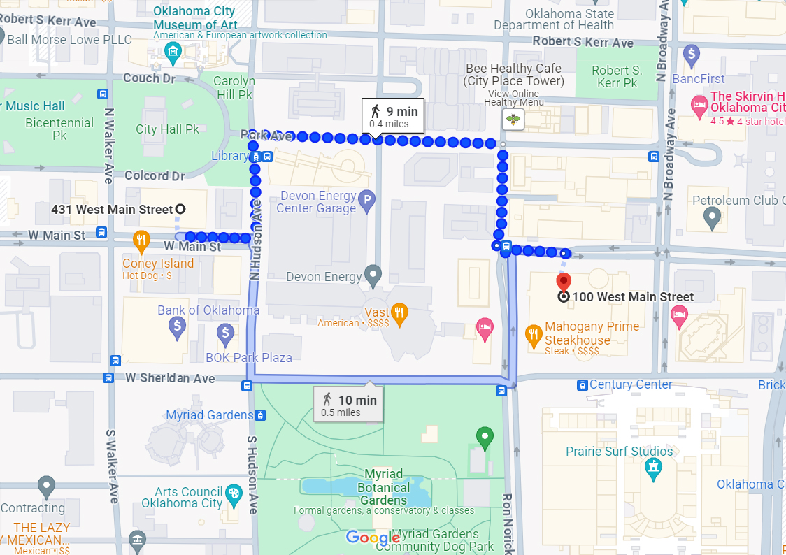

Agenda

Time | Topic | Presenters
8:00 a.m. | Breakfast and Business Meeting | Cindy Batt and Dan Molina  Program Co-Chairs
8:20 a.m. | Bios  - Brandon Brooks  - Joshua Busby
8:30 a.m. | Who Are We | Eric Long  Research Economist  Greater OKC Chamber of Commerce
9:15 a.m. | Break
9:30 a.m. | Oklahoma City Government 101 | David Holt  Mayor  City of Oklahoma City  Craig Freeman  City Manager  City of Oklahoma City
10:00 a.m. | Mock City Council | Class 41
11:00 a.m. | Break
11:15 a.m. | Travel to Griffin Media / News 9  100 W Main, Suite 100
11:45 a.m. | Arrive Griffin Media / News 9 | (Must arrive no later than 11:45!)
12:00 p.m. | Newscast and Tour
12:45 p.m. | Lunch
1:15 p.m. | The Business and Community Responsibility of Media | David Griffin  CEO  GComm Holdings
1:45 p.m. | Break
2:00 p.m. | The Media and Democracy | Ted Strueli  Executive Director  Oklahoma Watch  Paul Monies  Reporter  Oklahoma Watch
2:45 p.m. | The Future of Journalism | Clytie Bunyan  Managing Editor for Diversity, Community Engagement & Opinion  The Oklahoman
3:30 p.m. | Break
3:45 p.m. | Getting Involved | Cyndi Munson  State Representative, District 85  Oklahoma House of Representatives
4:30 p.m. | Bios  - A.J. Kirpatrick  - Kale Streeter
4:45 p.m. | Caucus | Cindy Batt and Dan Molina  Program Co-Chairs
5:15 p.m. | Adjourn

