Orientation Luncheon
Class 35

Thursday, August 25, 2016
11:45 a.m. – 1:30 p.m.
(Optional Tour of OSSM follows)

Shedrick Library, Oklahoma School of Science and Mathematics
NE 10th and Stiles Avenue

Between Broadway Extension (I-235) and Lincoln Blvd. on the north side of NE 10th Street.
Parking is available in a lot just to the right of the Shedrick Library

Dress
Business Casual

Special Notes
Please notify the LOKC Office, 463-3331 or info@lokc.org, if you will miss this session. The Orientation is not mandatory and does not count as an absence, but we need a good count for lunch.

Map

Shedrick Library, Oklahoma School of Science and Mathematics
NE 10th and Stiles Avenue
Between Broadway Extension (I-235) and Lincoln Blvd. on the north side of NE 10th Street.
Parking is available in a lot just to the right of the Shedrick Library

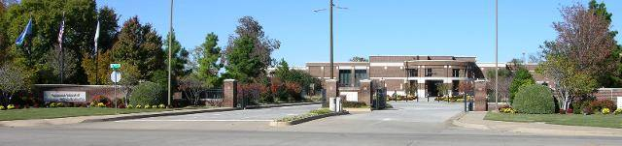
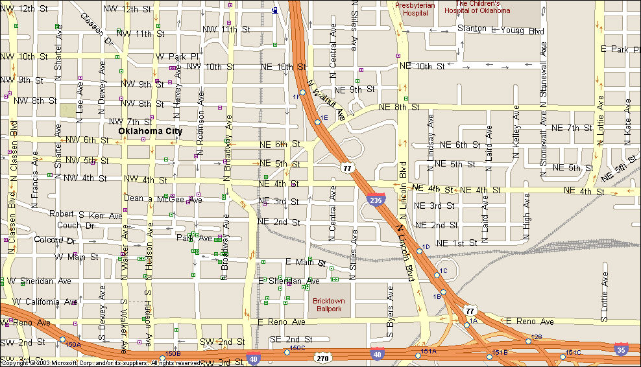
Shedrick Library
OK School of Science and Math

Enter from NE 10 between
Lincoln Blvd. and Stiles

Agenda

Upon Arrival | Distribution of Materials
11:45 a.m. | Lunch Seating
12:00 p.m. | Welcome | Kelly Fry and Dave Lopez  Program Co-Chairs
12:10 p.m. | Welcome to Leadership Oklahoma City, Inc. | Dr. Kay Martin  President, Leadership Oklahoma City
12:20 p.m. | Introductions of Class 35
1:00 p.m. | Overview of Program and Logistics | Kelly Fry and Dave Lopez  Program Co-Chairs
1:15 p.m. | Welcome to Oklahoma School of Science and Math | Dr. Frank Wang  President  Oklahoma School of Science and Mathematics
1:30 p.m. | Adjournment and Optional Tour of OSSM

